Project Introduction:
Welcome to the End-to-End DevSecOps Kubernetes Project guide! In this comprehensive project, we will walk through the process of setting up a robust Three-Tier architecture on AWS using Kubernetes, DevOps best practices, and security measures. This project aims to provide hands-on experience in deploying, securing, and monitoring a scalable application environment.
Project Overview:
In this project, we will cover the following key aspects:
- IAM User Setup: Create an IAM user on AWS with the necessary permissions to facilitate deployment and management activities.
- Infrastructure as Code (IaC): Use Terraform and AWS CLI to set up the Jenkins server (EC2 instance) on AWS.
- Jenkins Server Configuration: Install and configure essential tools on the Jenkins server, including Jenkins itself, Docker, Sonarqube, Terraform, Kubectl, AWS CLI, and Trivy.
- EKS Cluster Deployment: Utilize eksctl commands to create an Amazon EKS cluster, a managed Kubernetes service on AWS.
- Load Balancer Configuration: Configure AWS Application Load Balancer (ALB) for the EKS cluster.
- Amazon ECR Repositories: Create private repositories for both frontend and backend Docker images on Amazon Elastic Container Registry (ECR).
- ArgoCD Installation: Install and set up ArgoCD for continuous delivery and GitOps.
- Sonarqube Integration: Integrate Sonarqube for code quality analysis in the DevSecOps pipeline.
- Jenkins Pipelines: Create Jenkins pipelines for deploying backend and frontend code to the EKS cluster.
- Monitoring Setup: Implement monitoring for the EKS cluster using Helm, Prometheus, and Grafana.
- ArgoCD Application Deployment: Use ArgoCD to deploy the Three-Tier application, including database, backend, frontend, and ingress components.
- DNS Configuration: Configure DNS settings to make the application accessible via custom subdomains.
- Data Persistence: Implement persistent volume and persistent volume claims for database pods to ensure data persistence.
- Conclusion and Monitoring: Conclude the project by summarizing key achievements and monitoring the EKS cluster’s performance using Grafana.

INFRASTRUCTURE SETUP

Step 1: We need to create an IAM user and generate the AWS Access key
Create a new IAM User on AWS and give it to the AdministratorAccess for testing purposes (not recommended for your Organization's Projects)
Go to the AWS IAM Service and click on Users.
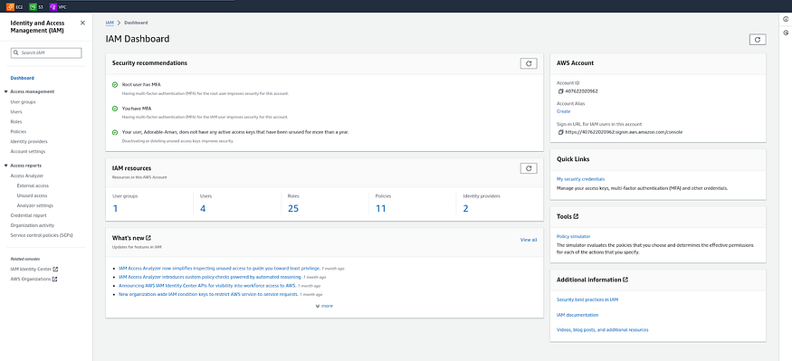
Click on Create user

Provide the name to your user and click on Next.
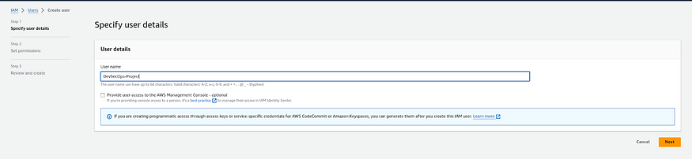
Select the Attach policies directly option and search for AdministratorAccess then select it.
Click on the Next.
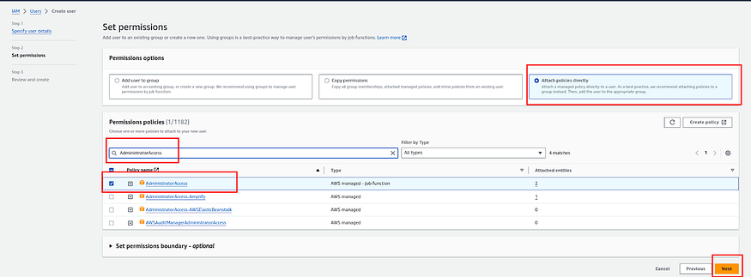

Click on Create user
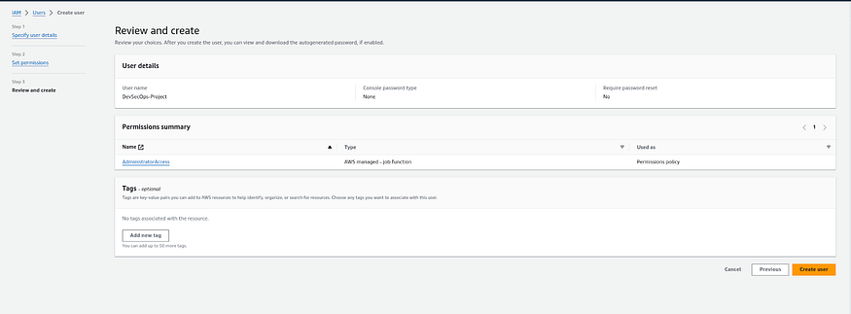
Now, Select your created user then click on Security credentials and generate access key by clicking on Create access key.
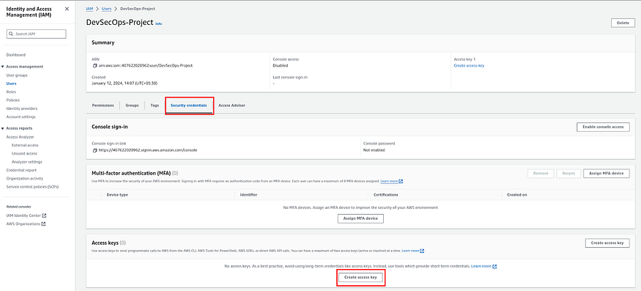

Select the Command Line Interface (CLI) then select the checkmark for the confirmation and click on Next.
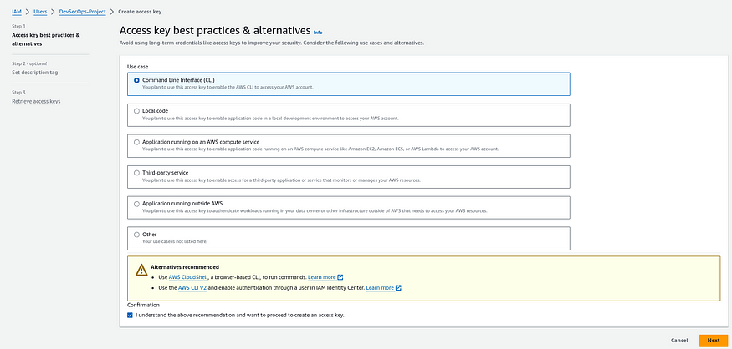
Provide the Description and click on the Create access key.
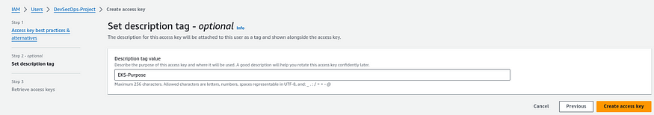
Here, you will see that you got the credentials and also you can download the CSV file for the future.
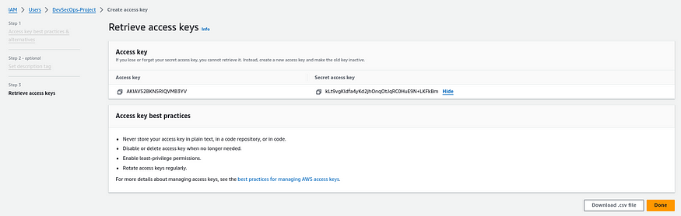

Now we have to add these credentials in our Jenkins server
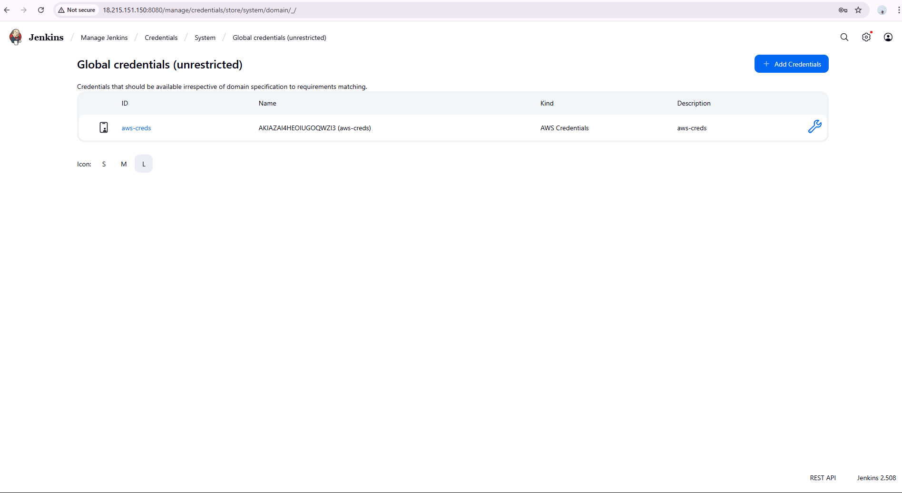

Step : 2 – Install necessary plugins in Jenkins
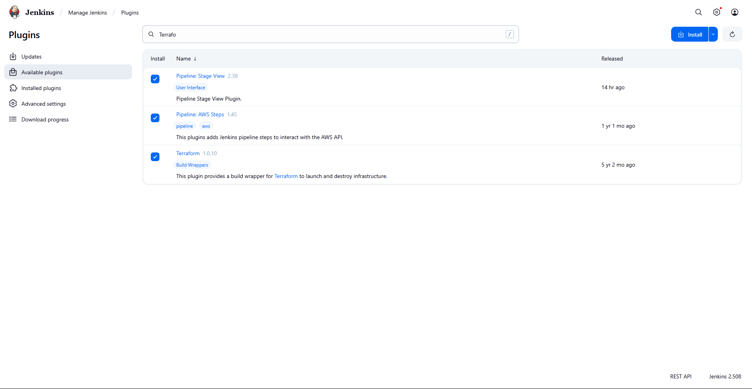

Step – 3 : Deploy Infrastructure using Terraform
We will be deploying EKS cluster using terraform modular infrastructure.
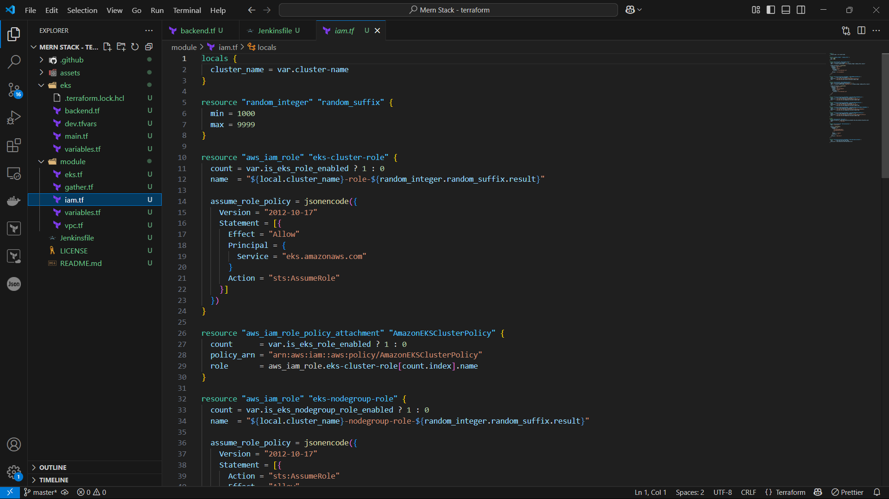

Step – 4: Pipeline Build
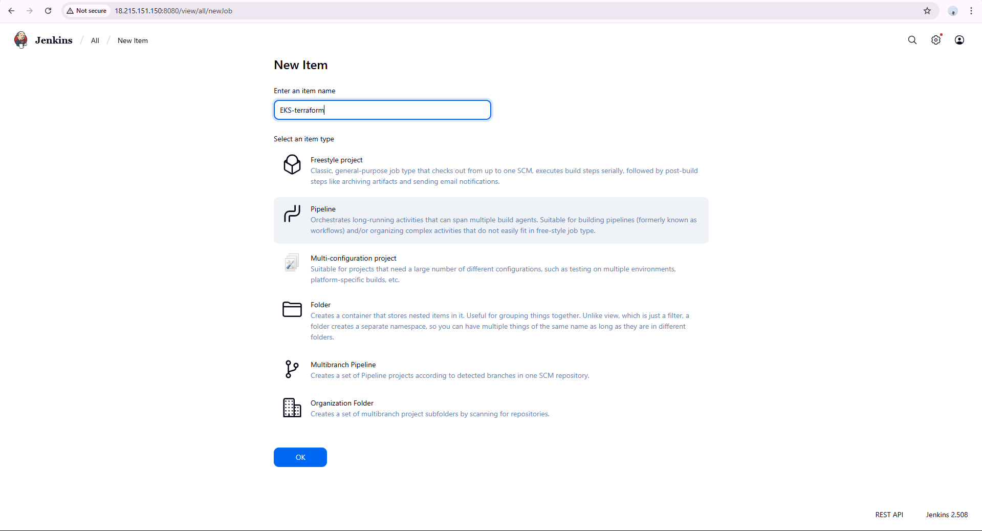
Define the pipeline script
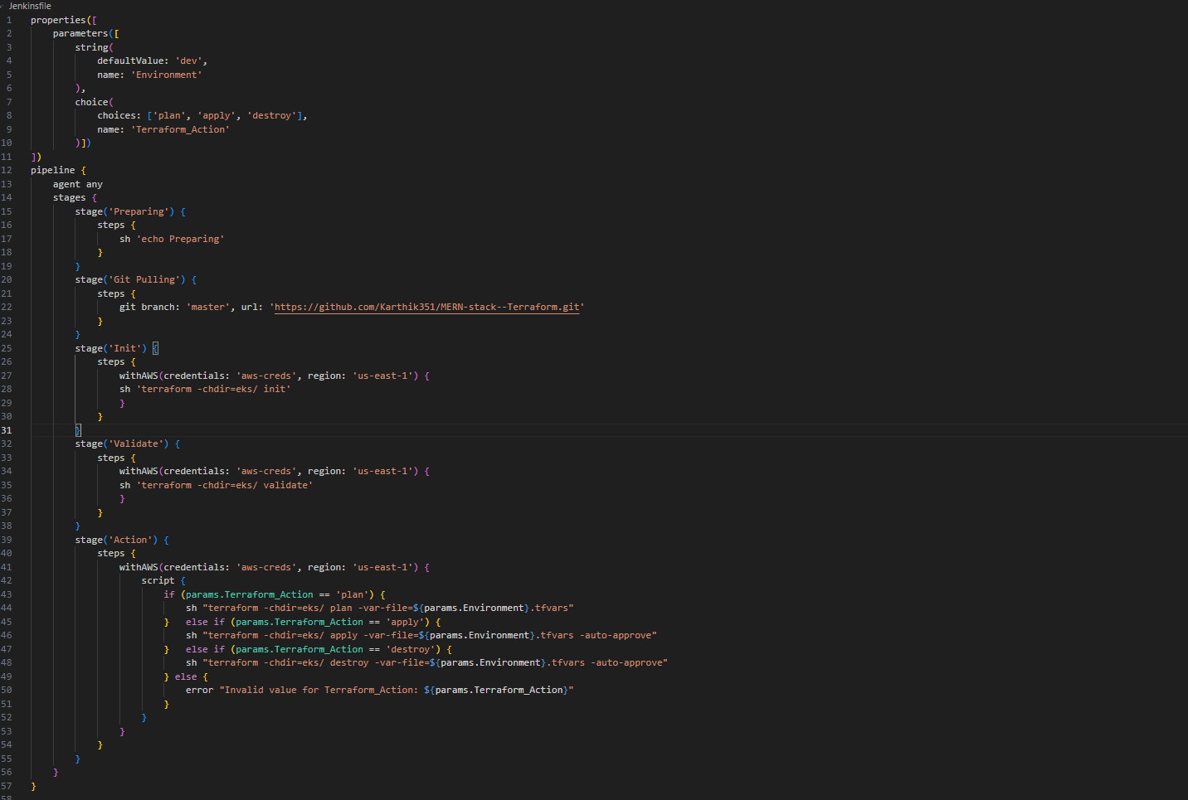
This Jenkins pipeline script is designed to automate the process of deploying infrastructure using Terraform. It provides a parameterized way to execute different Terraform actions (plan, apply, destroy) based on a given environment (like dev, prod, etc.).
The pipeline starts by declaring two input parameters using the properties block. The first is a string parameter named Environment with a default value of dev, which corresponds to the Terraform variable file (e.g., dev.tfvars). The second is a choice parameter named Terraform_Action, which allows users to choose between three options: plan, apply, or destroy. These inputs determine how Terraform will behave in the later stages.
The pipeline is structured using the declarative syntax and is set to run on any available Jenkins agent. It consists of several stages. The first stage, "Preparing", is a simple placeholder that echoes "Preparing" to indicate the pipeline is starting. The next stage, "Git Pulling", checks out the source code from the specified GitHub repository (https://github.com/Karthik351/MERN-stack--Terraform.git) using the master branch. This repository is assumed to contain the Terraform code and environment-specific variable files.
Following the Git checkout, the pipeline enters the "Init" stage, where the Terraform working directory (eks/) is initialized using terraform init. This is done inside a withAWS block, which provides the required AWS credentials (aws-creds) and sets the region to us-east-1. This ensures the Terraform provider can authenticate with AWS.
The "Validate" stage performs a Terraform validation using terraform validate to check the configuration for syntax correctness and logical issues. Again, this is wrapped within the AWS credentials block to ensure proper authentication.
The final stage, "Action", is the heart of the pipeline. It dynamically determines which Terraform command to run based on the Terraform_Action parameter. If the value is plan, it runs terraform plan using the specified environment's .tfvars file to preview the changes. If the action is apply, it provisions the infrastructure with terraform apply and auto-approves the plan. If the action is destroy, it tears down the infrastructure using terraform destroy, also auto-approved. If any other value is passed, the pipeline throws an error to avoid invalid operations.

Now build the pipeline using parameters.
- PLAN
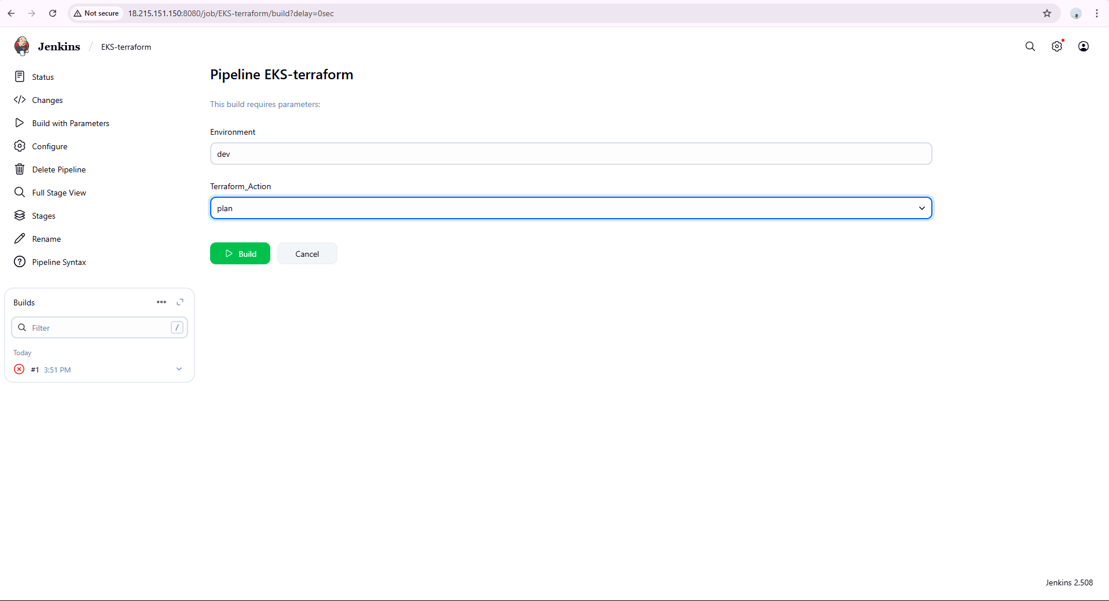
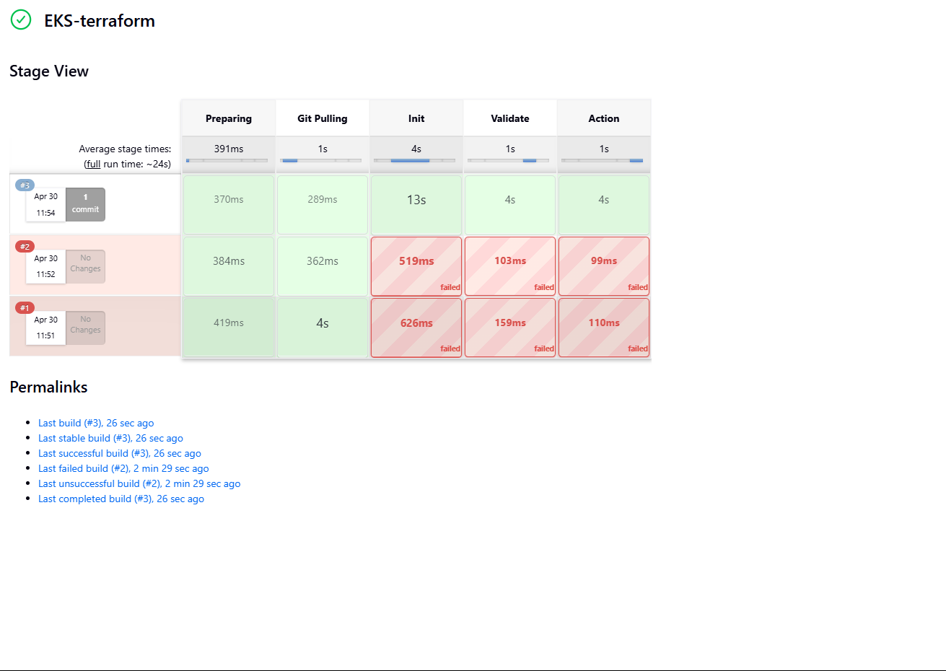

- APPLY
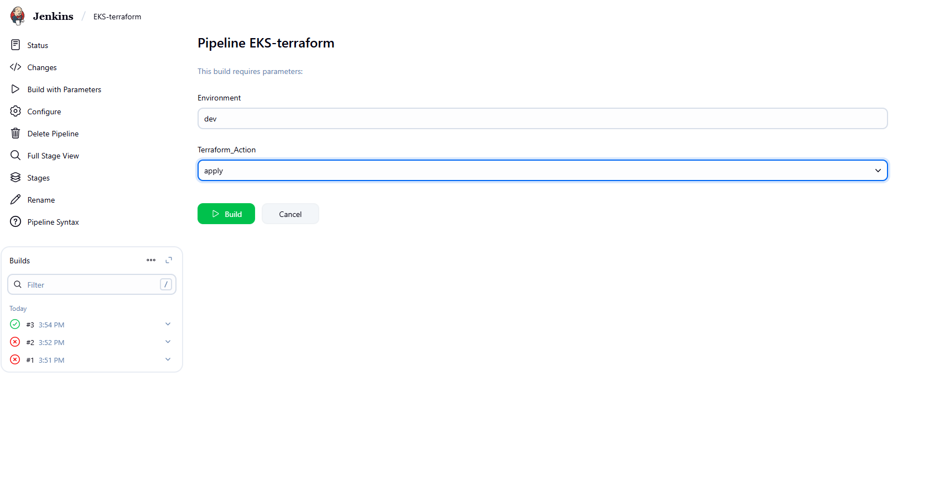
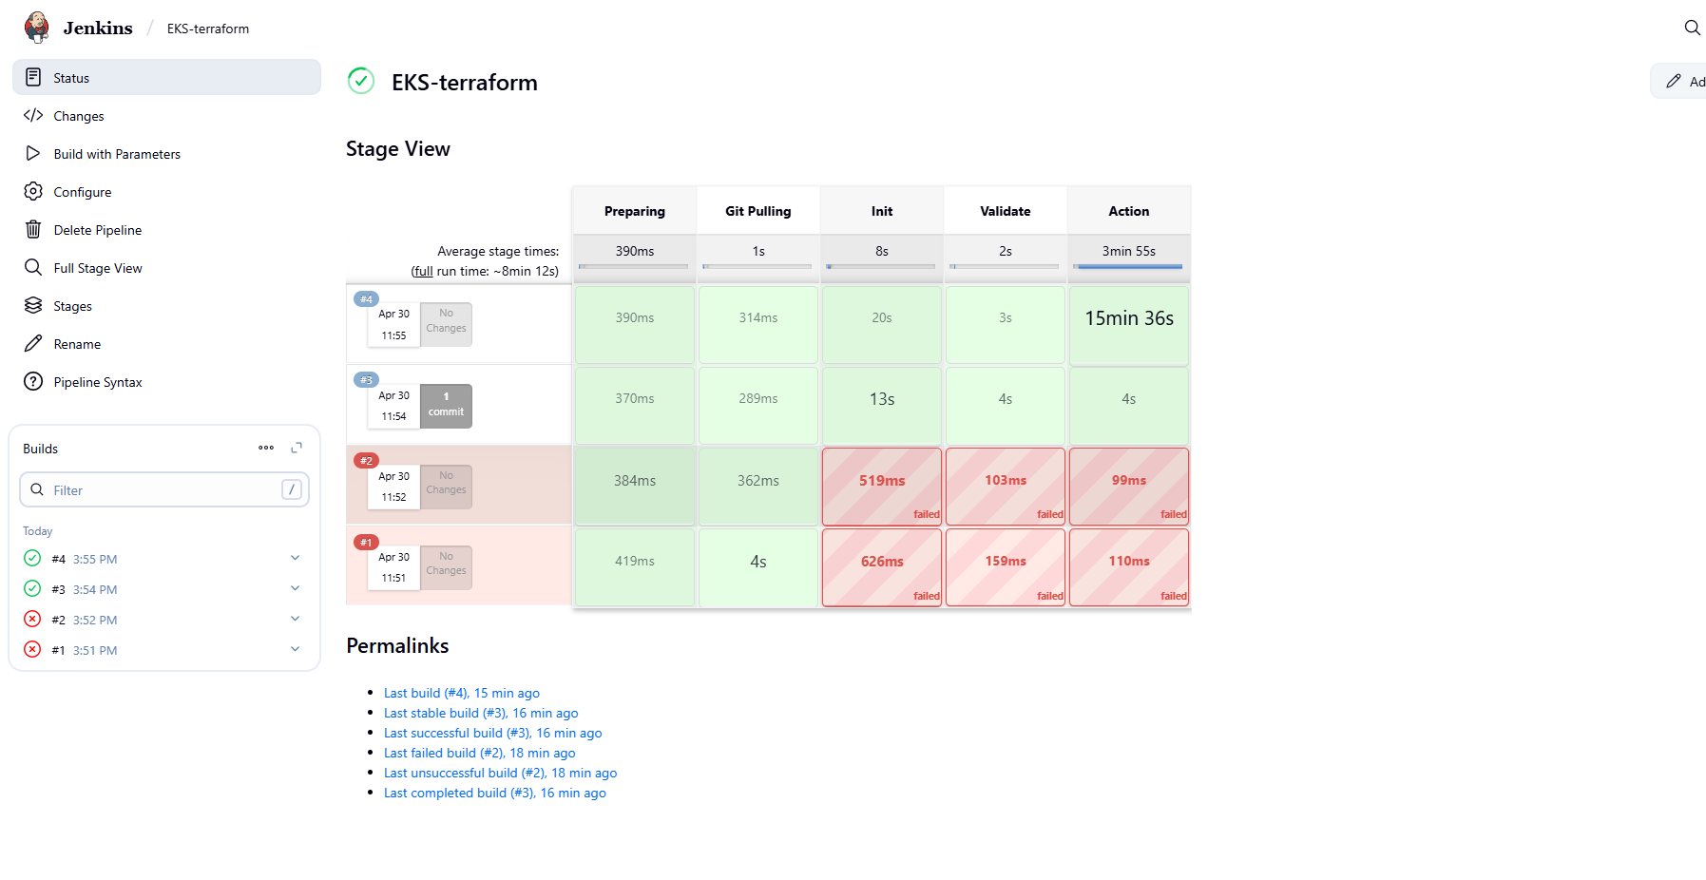
As we can see our pipeline is built successfully. Our EKS cluster got created.
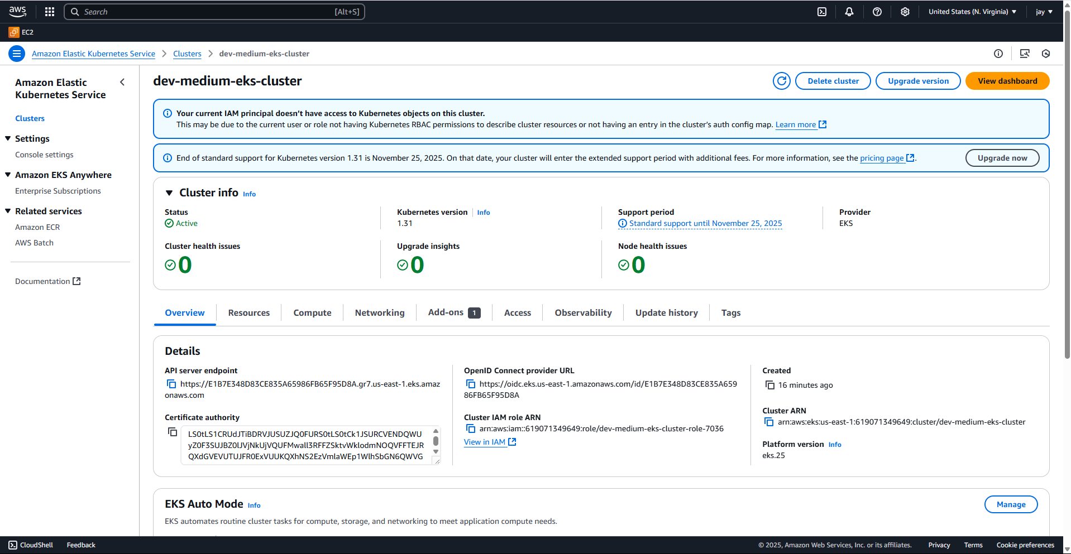

Step : 4 – Launch a Jump Server
As our EKS cluster in the VPC it is private cluster by default, we are creating a jump server so that whoever has the access for the jump server they can communicate with the EKS cluster. But we restrict access to this server only for limited people.
While launching the jump server we are using the VPC where EKS is created and public subnet.
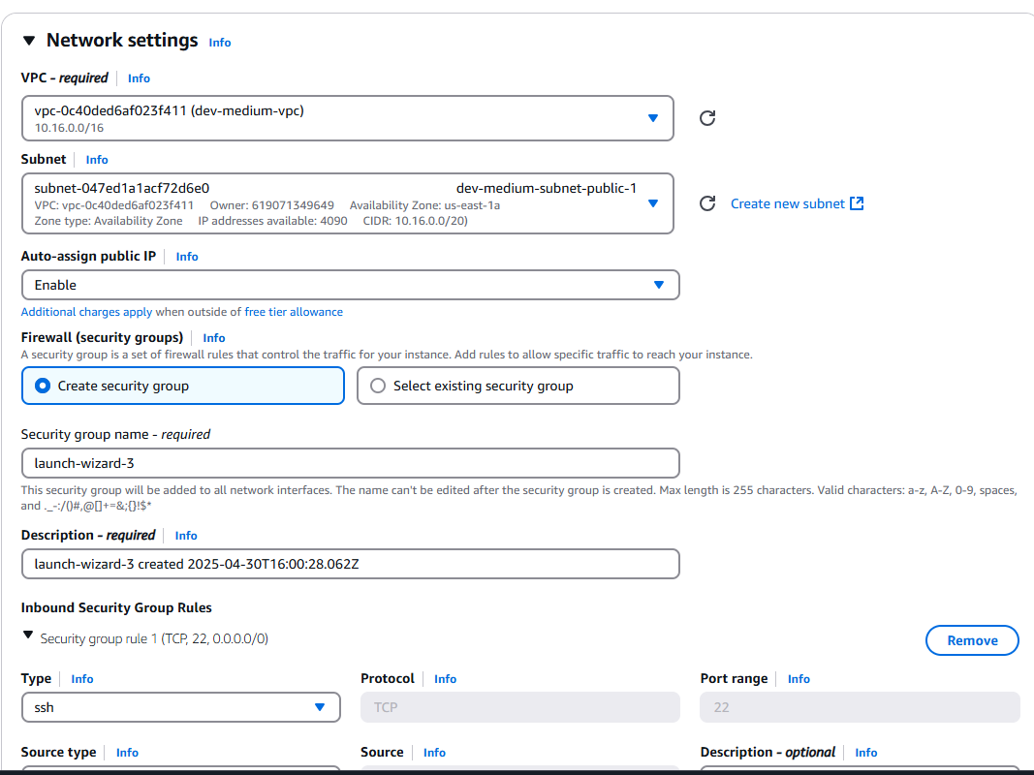

Using user data we install kubectl, helm, eksctl, awscli
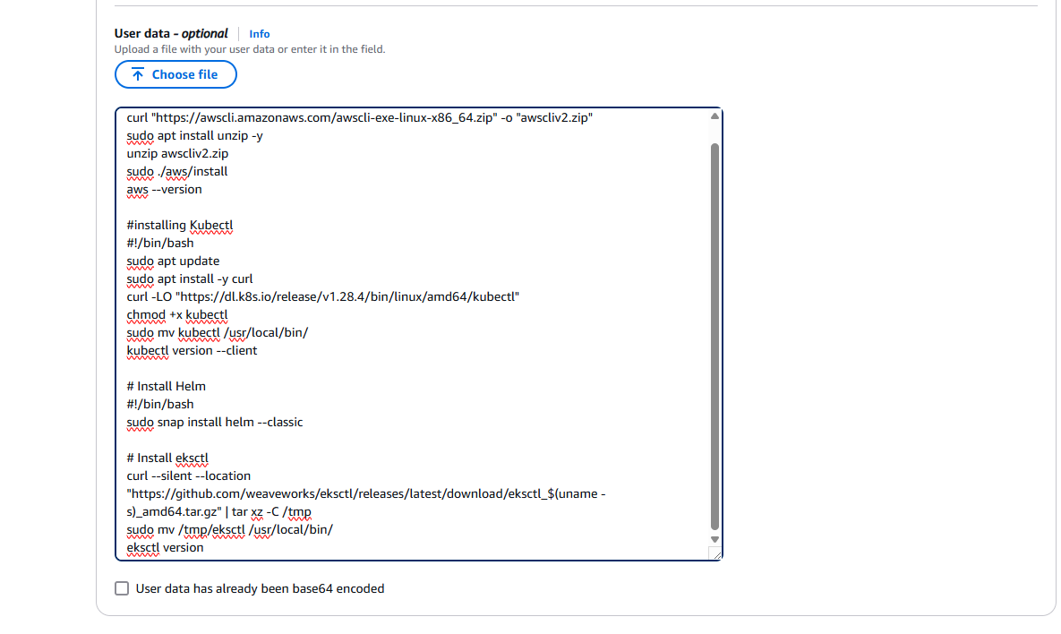

Our jump server is launched successfully.
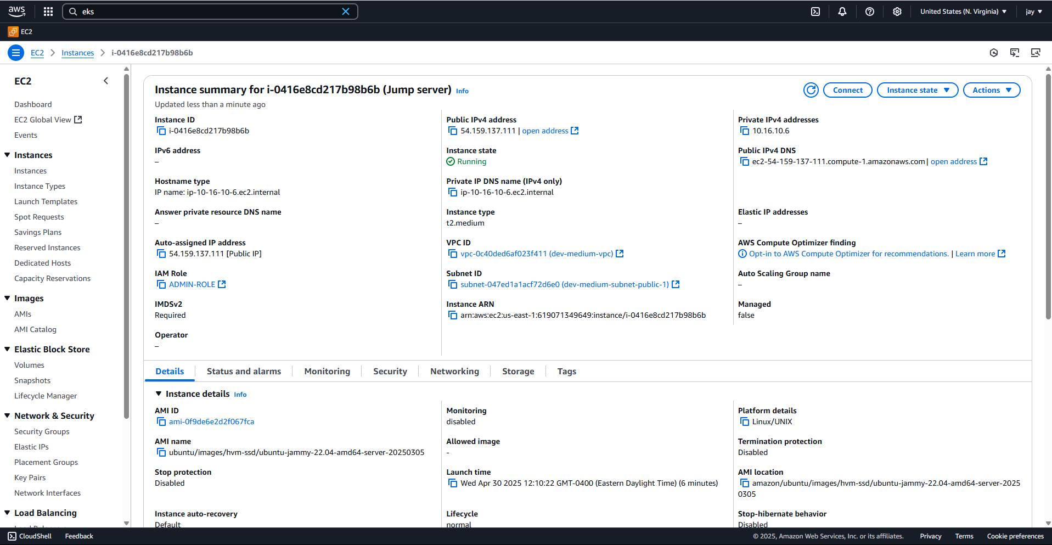

Let us update the kubeconfig in jump server.

As we can see we can communicate with the EKS cluster from Jump server.
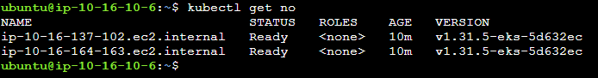

Lets try to communicate with EKS from our Jenkins server.
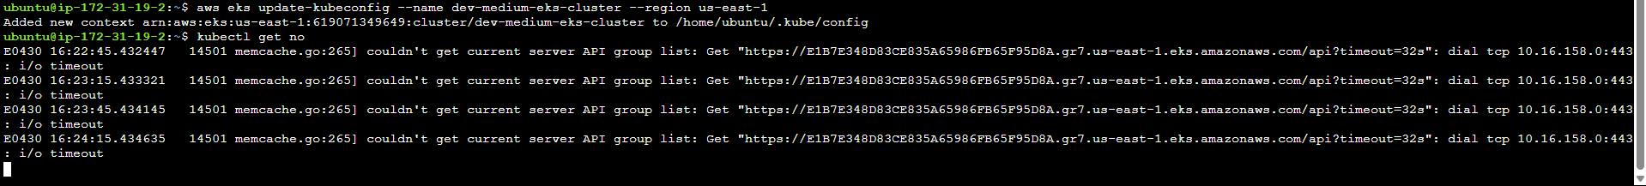
As we can see we get error while communicating because we only access the EKS from jump server.

Step 5: Now, we will configure the Load Balancer on our EKS because our application will have an ingress controller.
Download the policy for the LoadBalancer prerequisite.
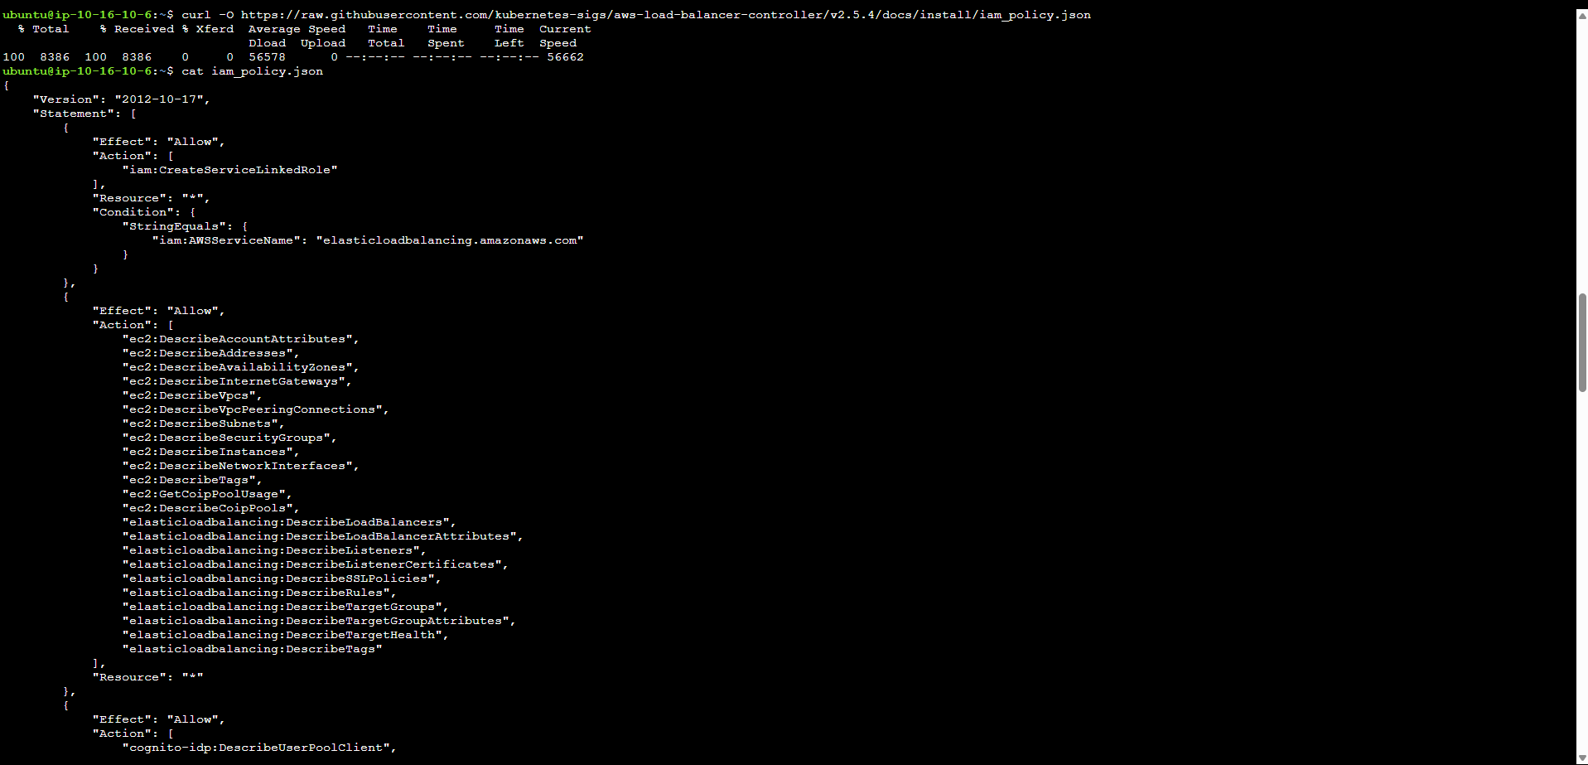

We are tying up the service account pod with a IAM user or role. Using this policy we grant permissions to the EKS pod so that it can create load balancer using that service account.

Create the IAM policy using the below command.
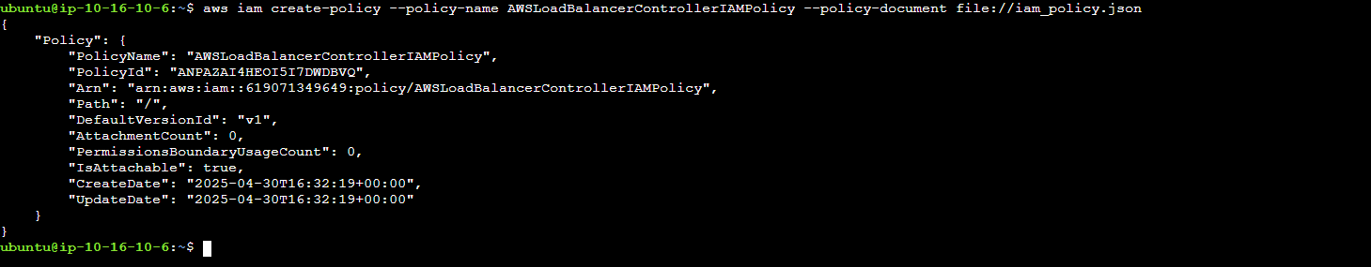

Now we have created the IAM policy. Let us create the service account in the Kubernetes cluster.
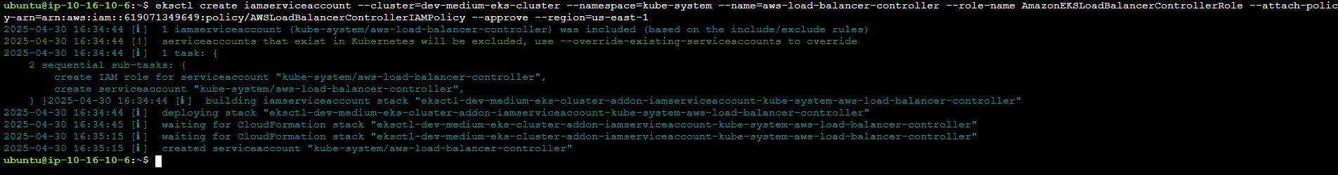
Our service account is successfully created.
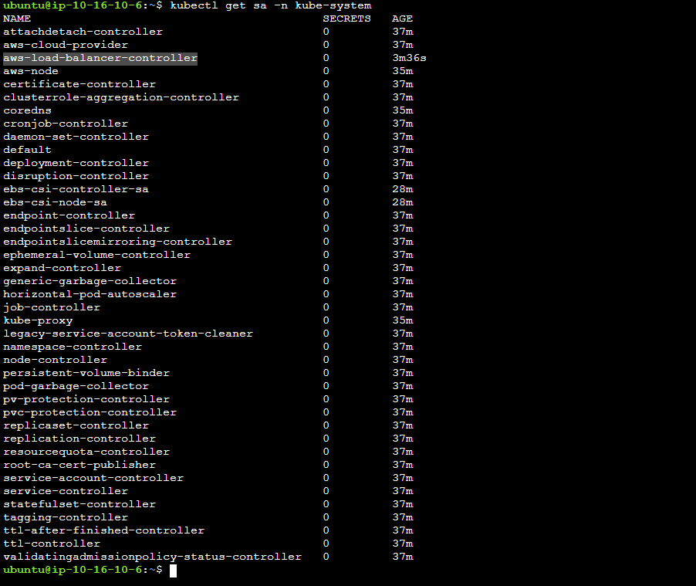

Now using helm we deploy the ingress controller onto the Kubernetes cluster.
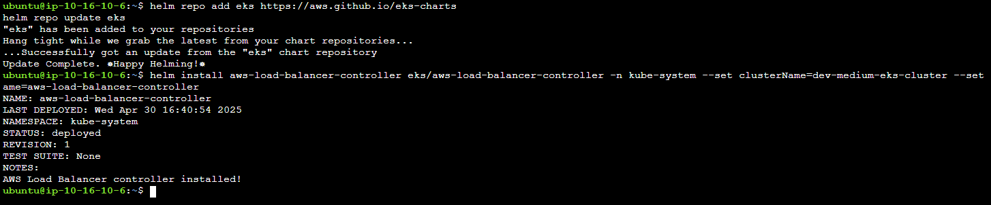
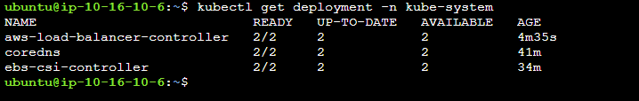

Step 7: Install & Configure ArgoCD
We will be deploying our application on a three-tier namespace. To do that, we will create a three-tier namespace on EKS
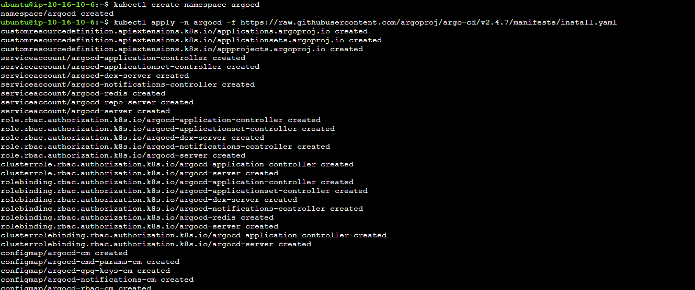

Edit the ArgoCD server service to Load balancer.
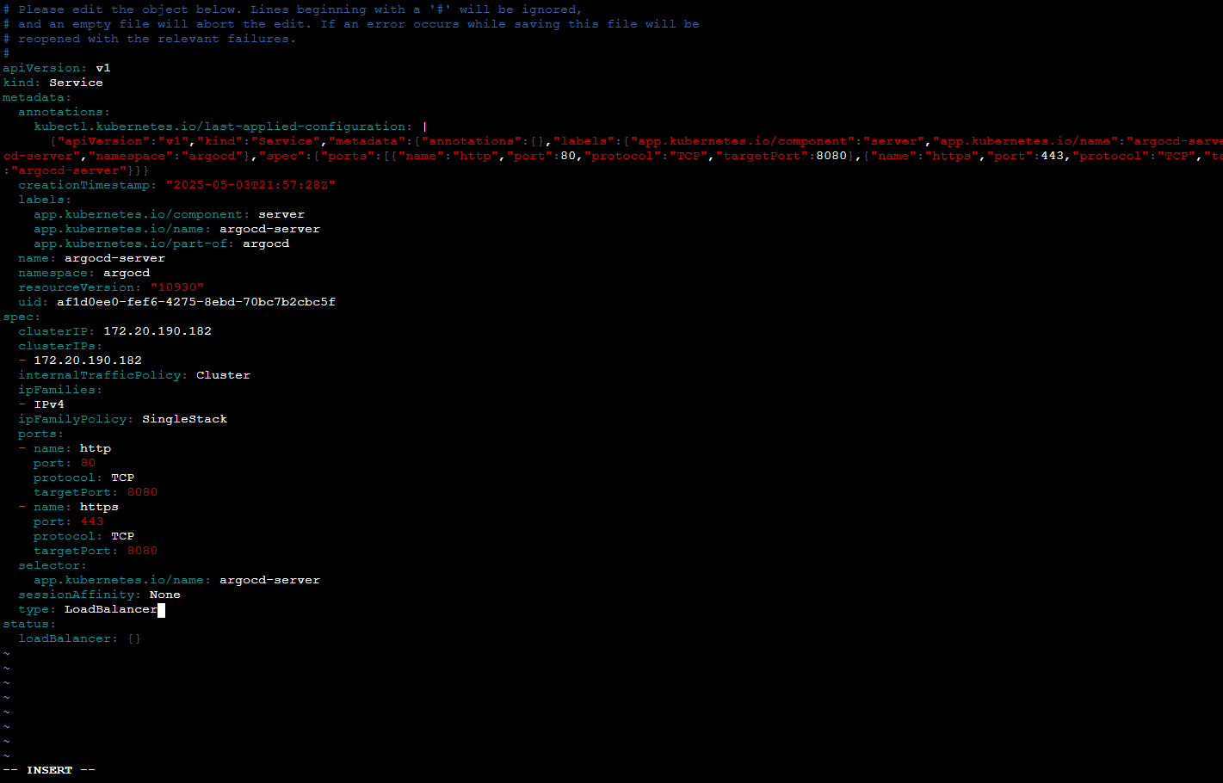

ArgoCD is successfully installed and running
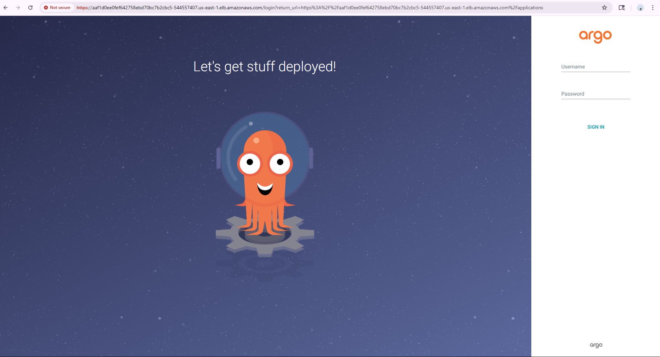
Edit the secrets of argocd admin and use the password while logging in
Decode the password using base64 decoder.
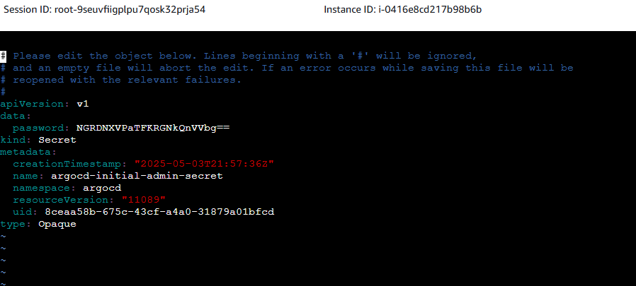

SOURCE CODE MANAGEMENT

Step 9: Now, we have to configure Sonarqube for our DevSecOps Pipeline
To do that, copy your Jenkins Server public IP and paste it on your favorite browser with a 9000 port
The username and password will be admin
Click on Log In.
Generate a token and register it in Jenkins
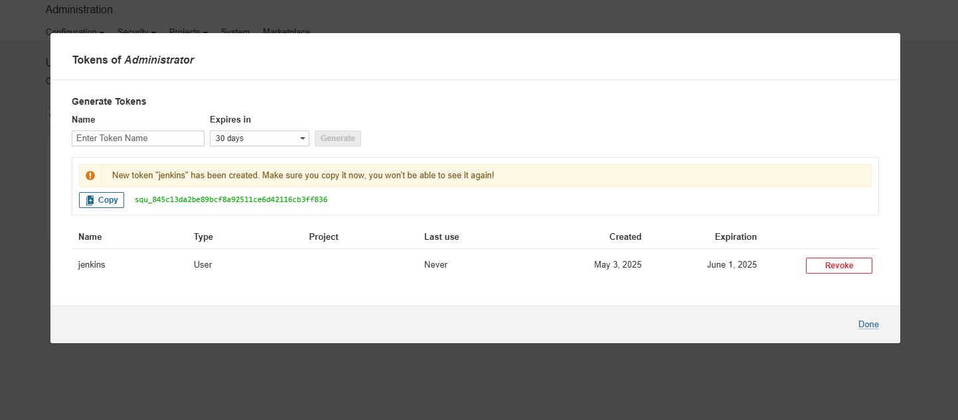

Create a webhook and specify Jenkins URL
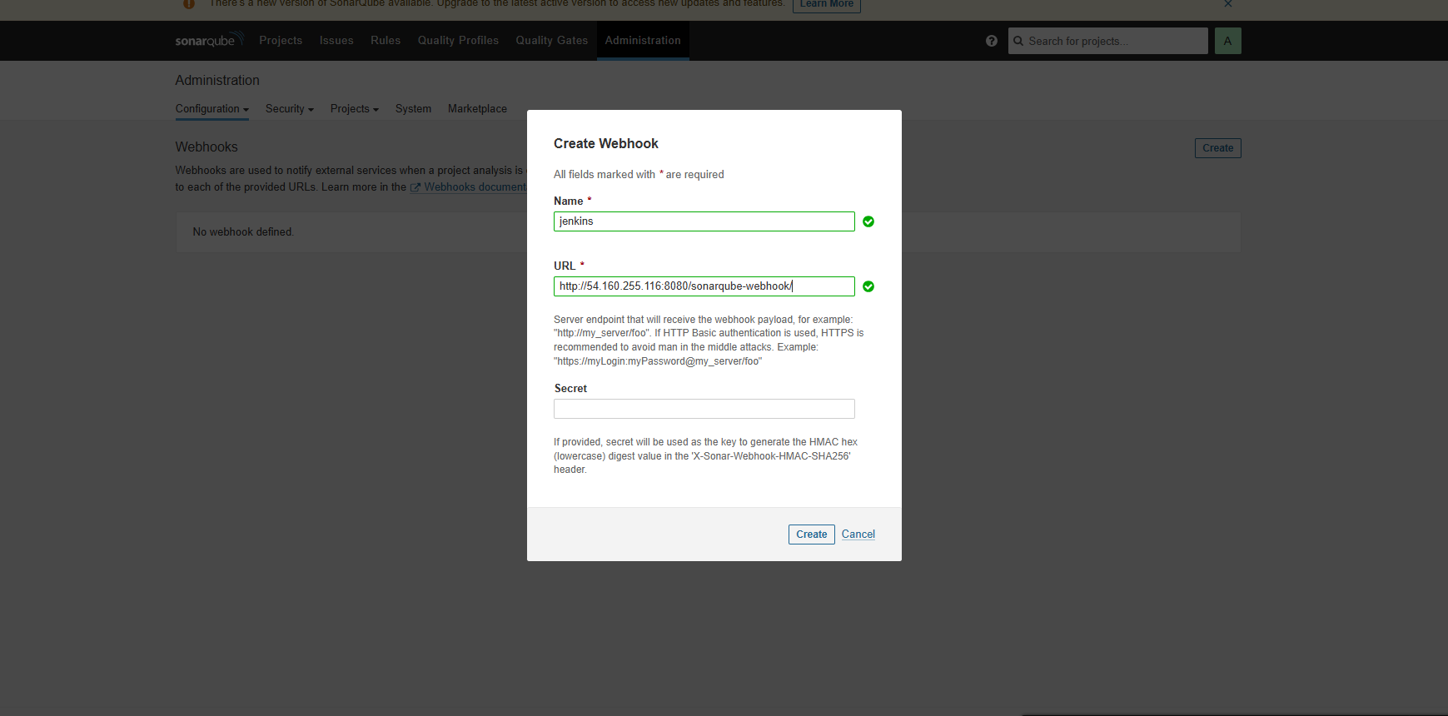

Step 8: We need to create Amazon ECR Private Repositories for both Tiers (Frontend & Backend)
We will create 2 repositories for frontend and backend.
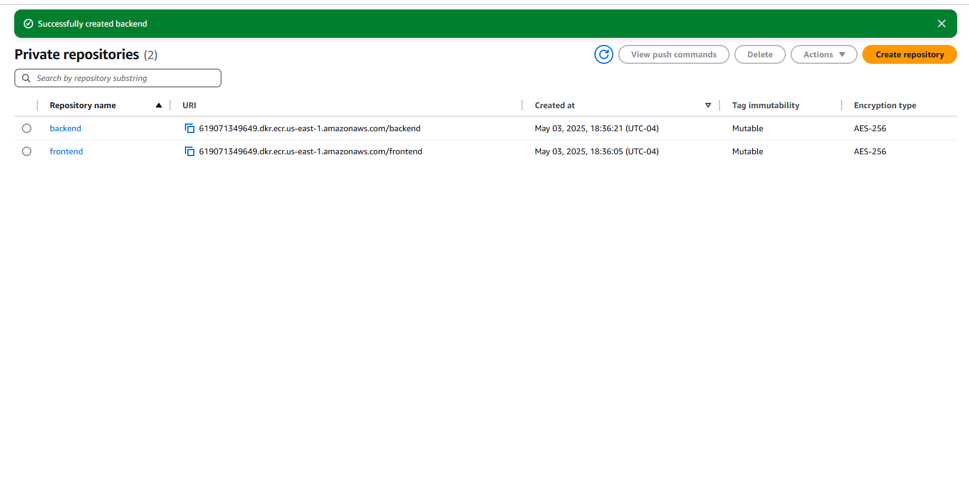
Register the ECR repos in the Jenkins server in the credentials section.
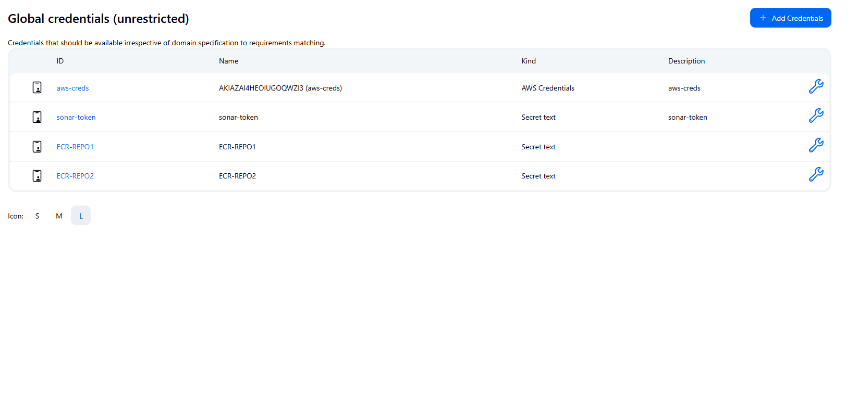

Register Git credentials in Jenkins global credentials.
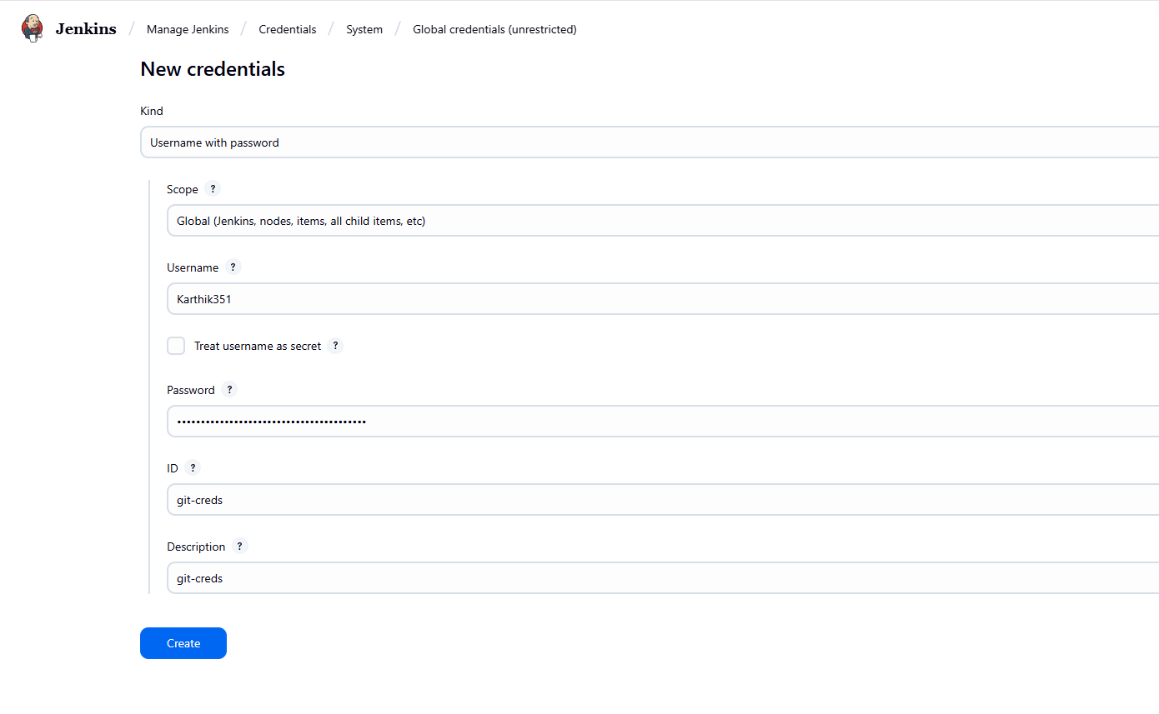

Configure all the required tools in the Jenkins tools section.
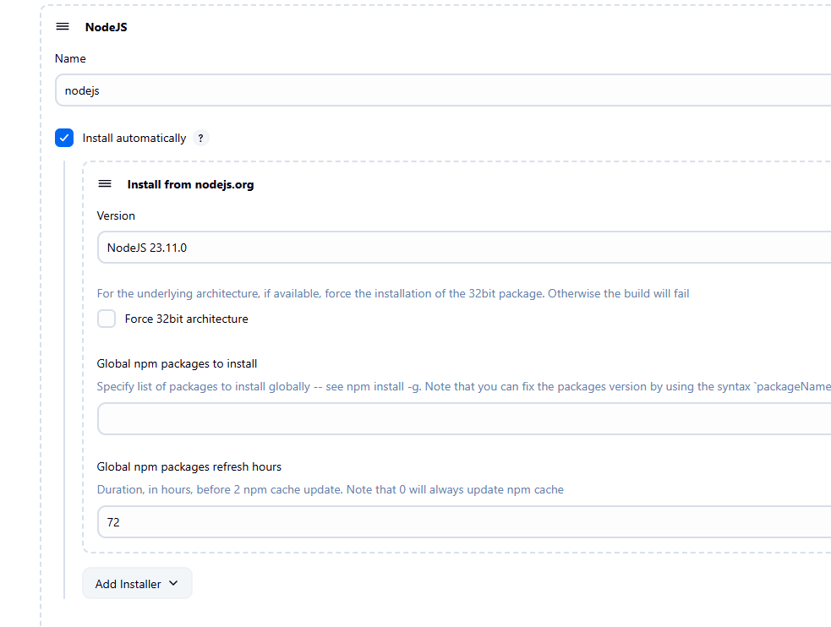

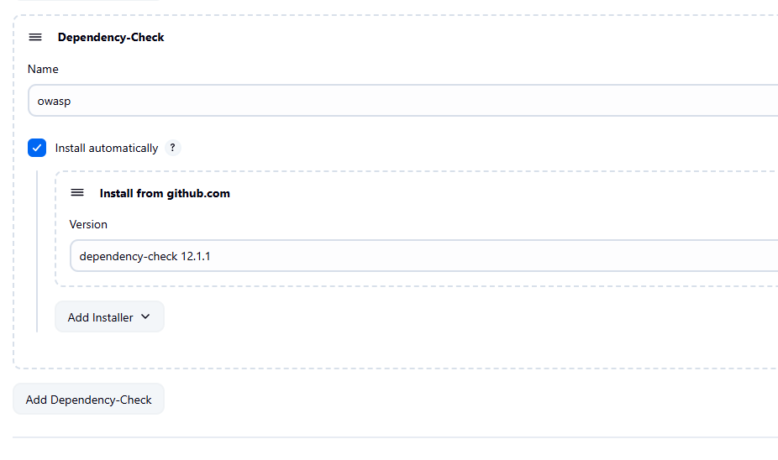

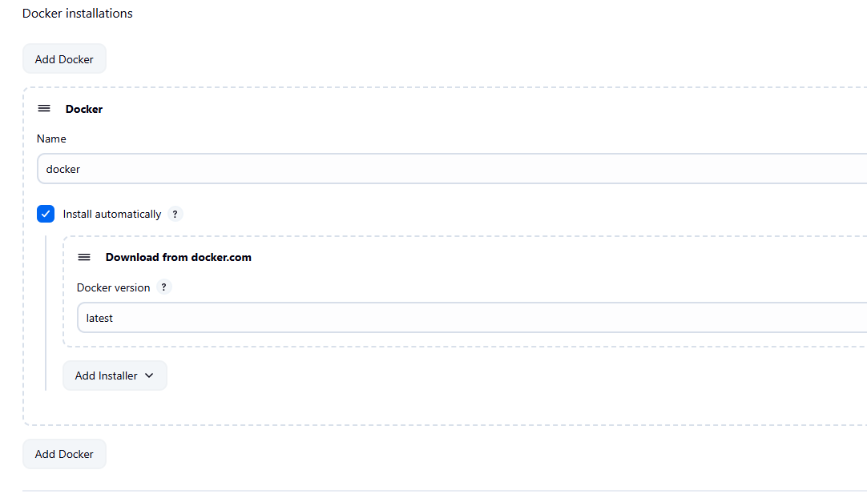

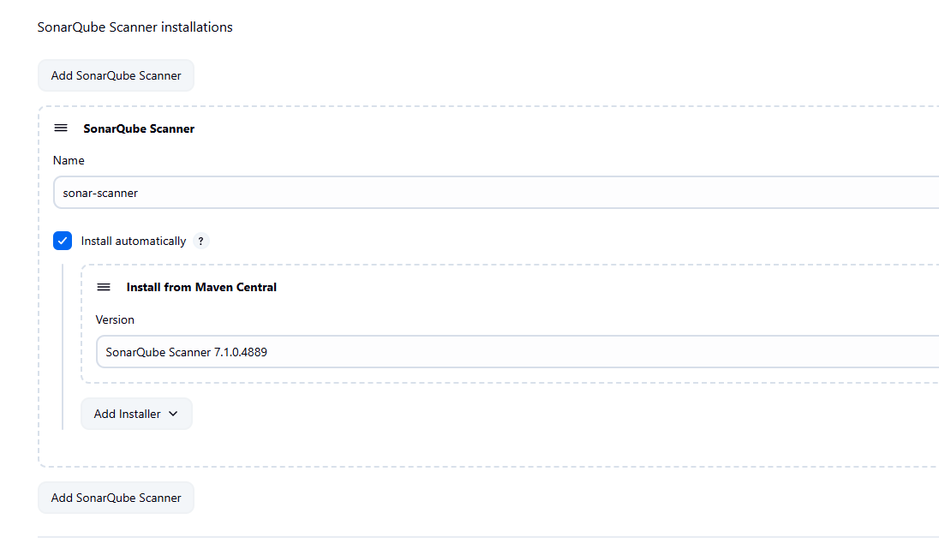

Now, we are ready to create our Jenkins Pipeline to deploy our Frontend and Backend Code.
Go to Jenkins Dashboard
Click on New Item and create a pipeline

Use the pipeline script.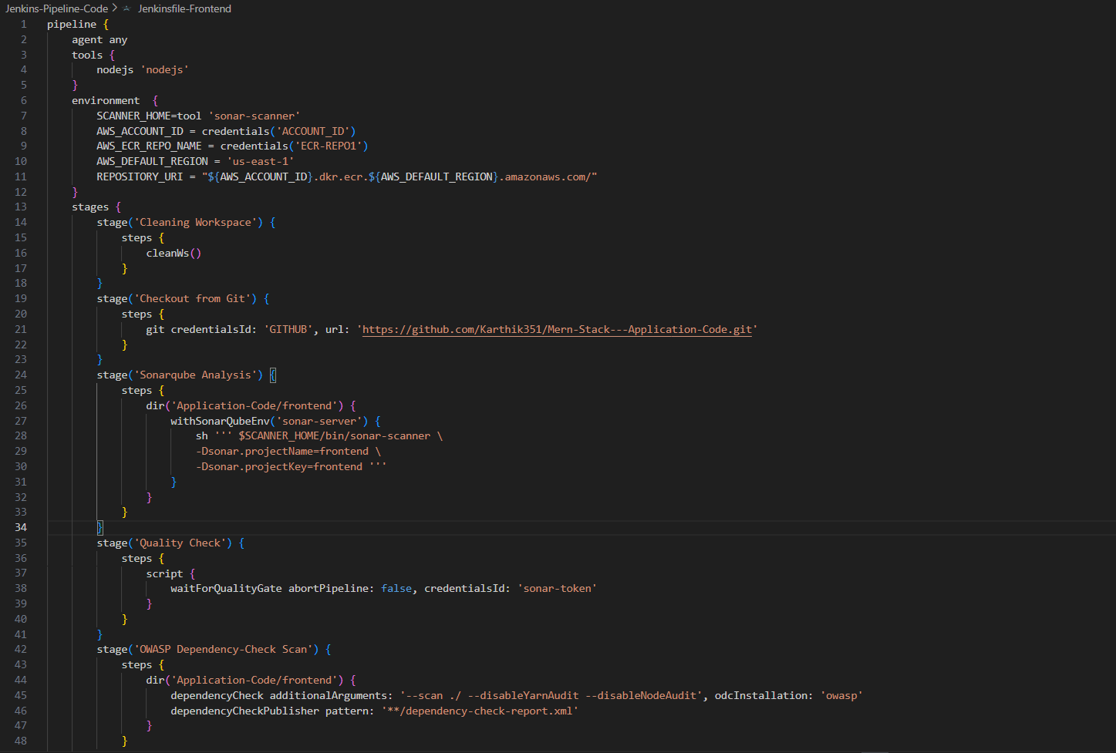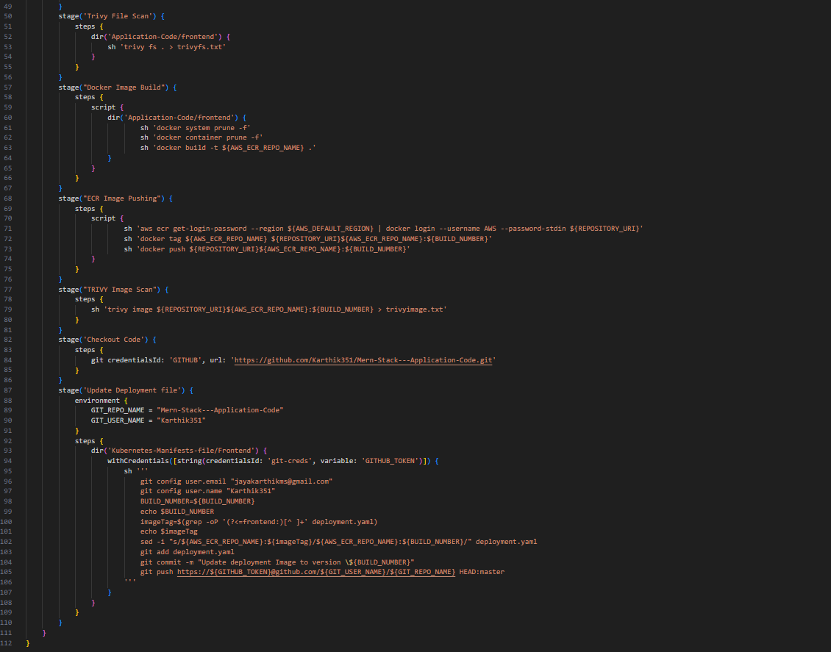
This Jenkins pipeline automates a full CI/CD workflow for a MERN stack application's frontend. It includes steps for code checkout, code quality analysis, vulnerability scanning, Docker image creation and pushing to AWS ECR, and finally updating the Kubernetes deployment manifest in the GitHub repository.

✅ Pipeline Configuration
The pipeline uses a general-purpose agent any, which allows execution on any available Jenkins agent. It declares tools like Node.js (nodejs) and sets environment variables for AWS ECR (AWS_ACCOUNT_ID, AWS_ECR_REPO_NAME, AWS_DEFAULT_REGION, and REPOSITORY_URI) and for the SonarQube scanner tool (SCANNER_HOME).

🧹 Cleaning and Checkout
The Cleaning Workspace stage clears any previous workspace artifacts. The Checkout from Git stage clones the source code repository using the GITHUB credentials. This ensures a clean and updated working copy of the MERN frontend code.

📊 Code Quality: SonarQube
In the Sonarqube Analysis stage, the pipeline navigates into the frontend code directory and runs a static code analysis using SonarQube with sonar-scanner. It specifies the project name and key for tracking in the SonarQube dashboard. The next Quality Check stage uses waitForQualityGate, ensuring the pipeline only proceeds if the code passes quality thresholds, authenticated by a SonarQube token.

🔒 Security Scanning: OWASP and Trivy
The OWASP Dependency-Check Scan runs a scan against dependencies for known vulnerabilities, disabling unnecessary audits like Yarn and Node to speed up the process. A report is published after the scan. The Trivy File Scan checks the application directory for file-level vulnerabilities, saving the output to trivyfs.txt.

🐳 Docker Image Build and Push
In the Docker Image Build stage, the workspace is cleaned of old containers and images before building a Docker image for the frontend, tagged using the ECR repository name. The next ECR Image Pushing stage authenticates to AWS ECR, tags the built image with the Jenkins build number, and pushes it to the repository. REPOSITORY_URI and BUILD_NUMBER ensure consistent tagging.

🛡️ Trivy Image Scan
This stage scans the built and pushed Docker image using Trivy to detect vulnerabilities inside the container image. The output is stored in trivyimage.txt for review.

🛠️ GitOps: Deployment File Update
Finally, the pipeline updates the Kubernetes deployment manifest. It checks out the GitHub repo again, then enters the Kubernetes-Manifests-file/Frontend directory. Using a GitHub token (git-creds), it sets up Git config and replaces the old image tag in deployment.yaml with the new BUILD_NUMBER. It commits and pushes the change back to the master branch.

Build the pipeline.
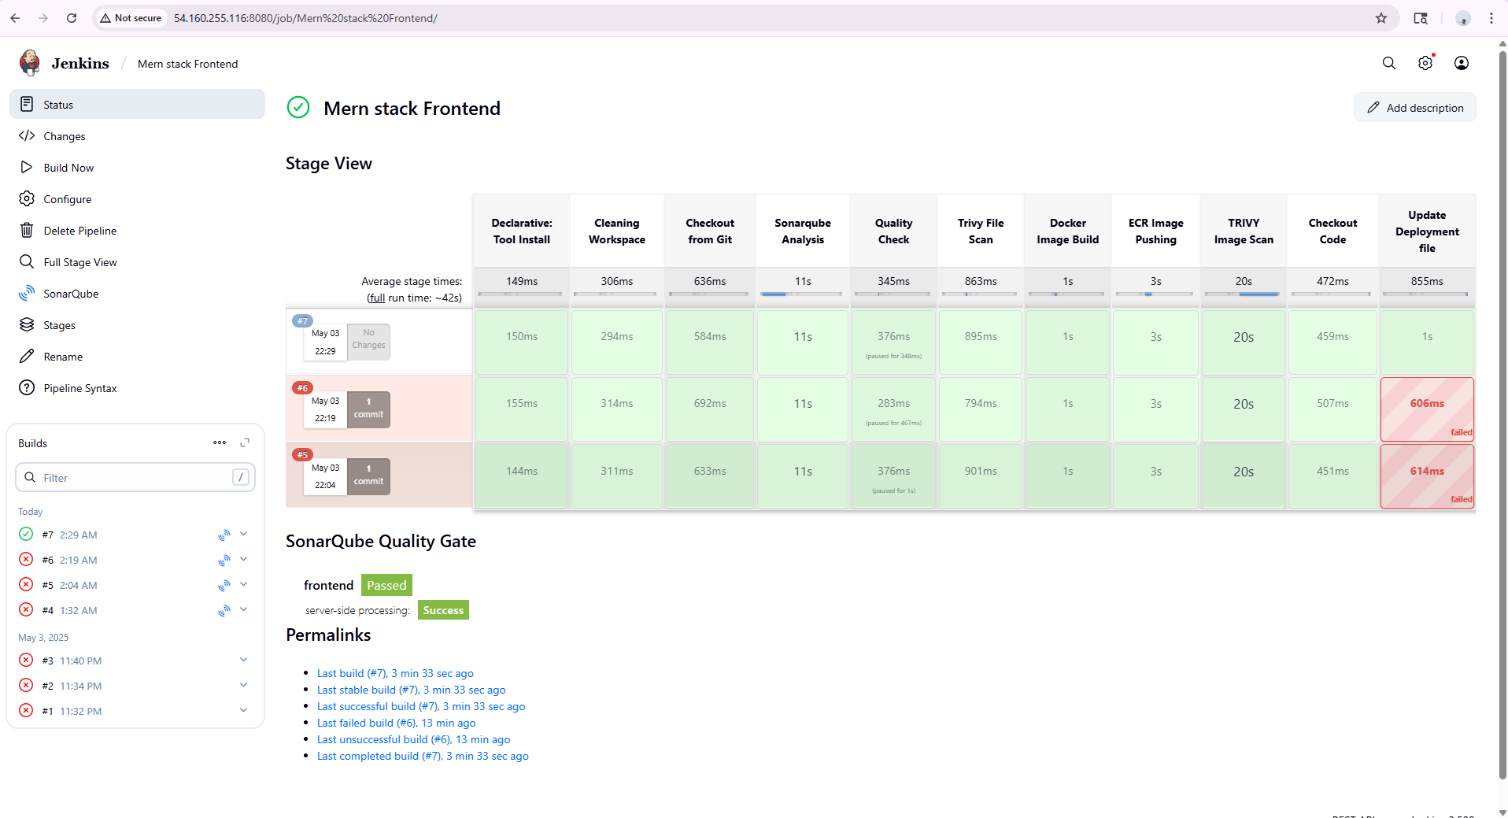

As we can see that our build is successful.
Sonarqube quality scan successfully passed.
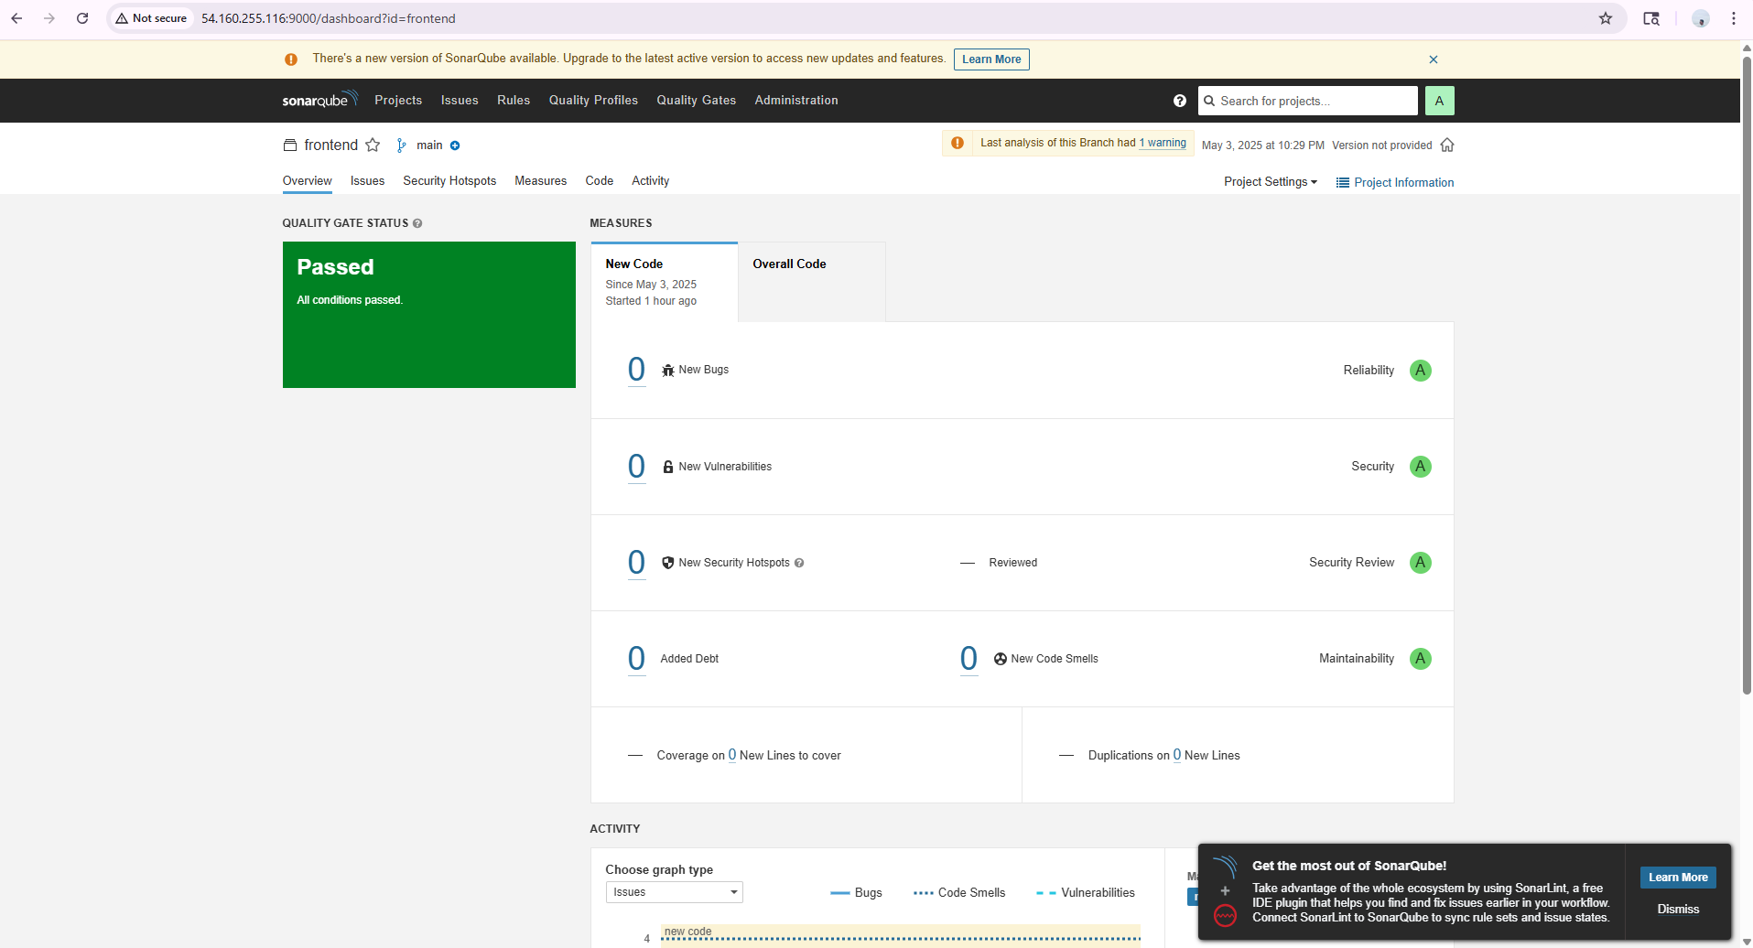

Our images has been pushed to ECR repository.
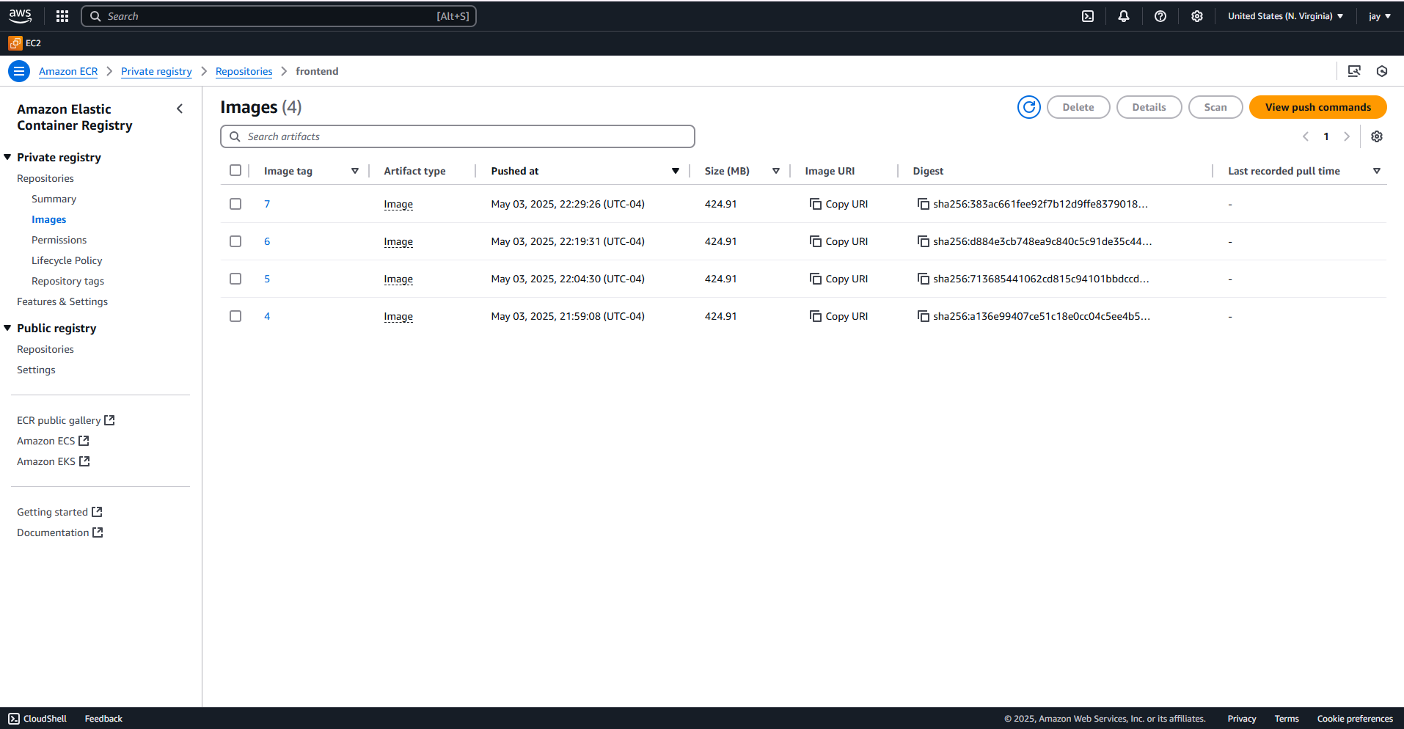

Our deployment yaml file in the github has been updated with the new image URI.
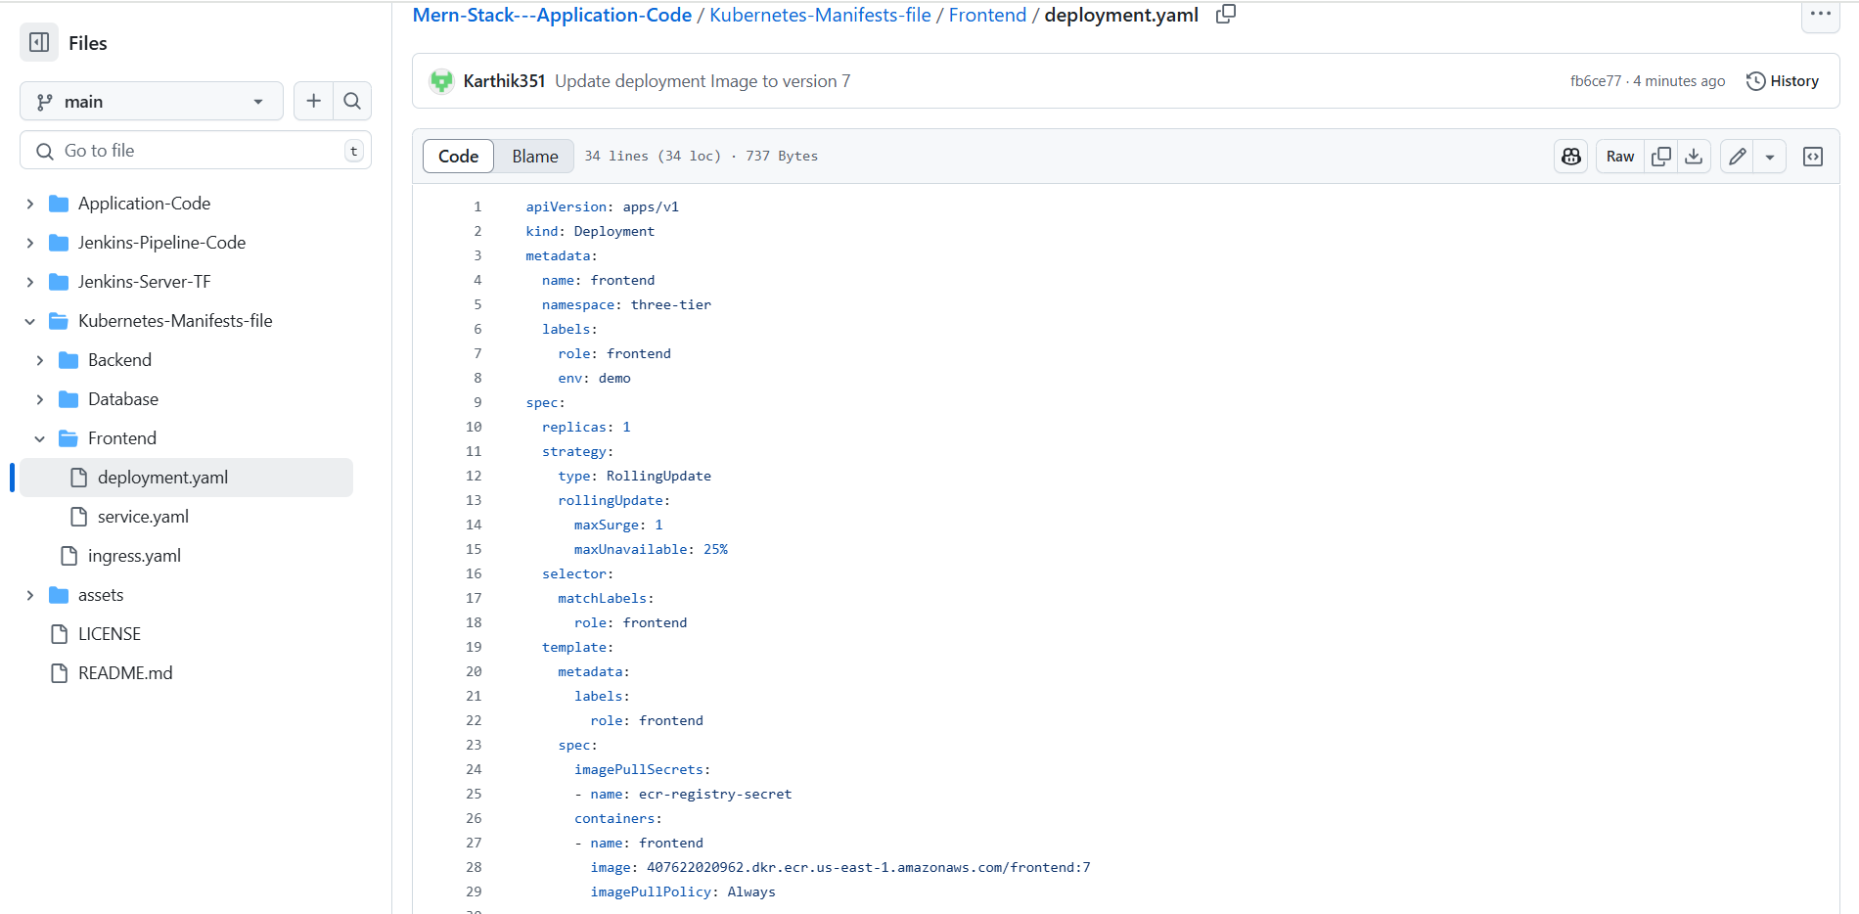

Repeat the same process with the backend as well.

